**Date**: -28/04/2023

**Ex.no**: -1

**DDL Commands – CREATE, ALTER, DROP**

**Aim:**

To Create, Alter and Drop the table using Data Definition Language.

**CREATE TABLE**

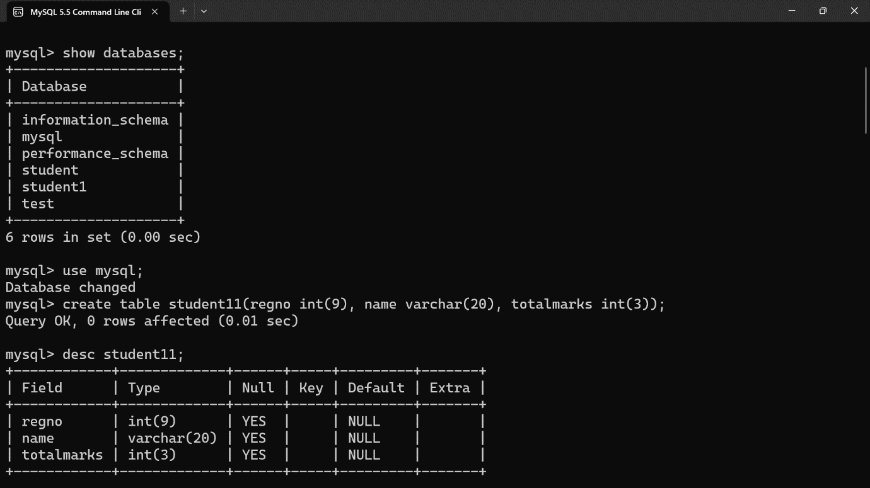

**ALTER A TABLE** 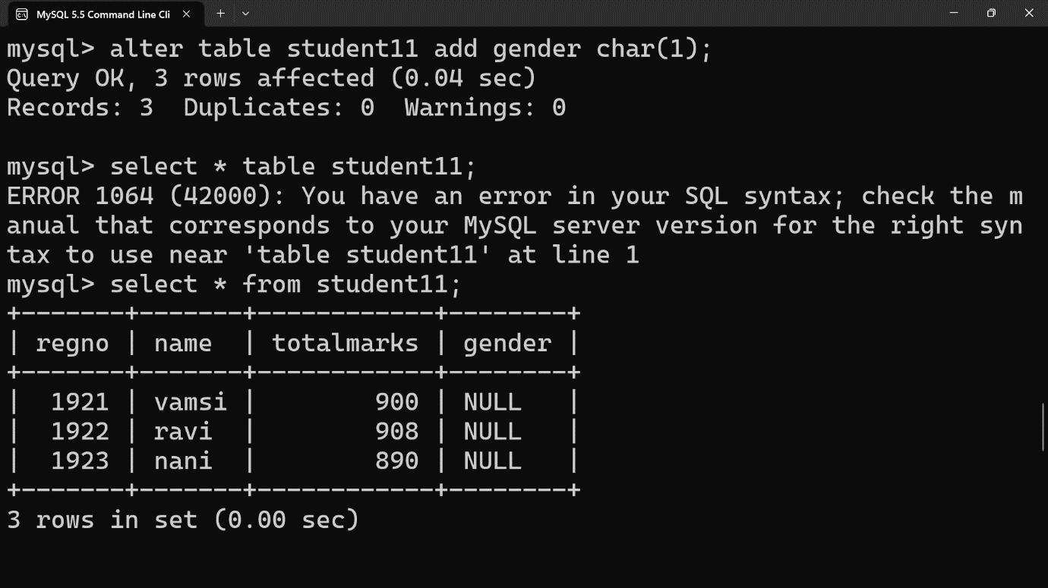

**Delete**

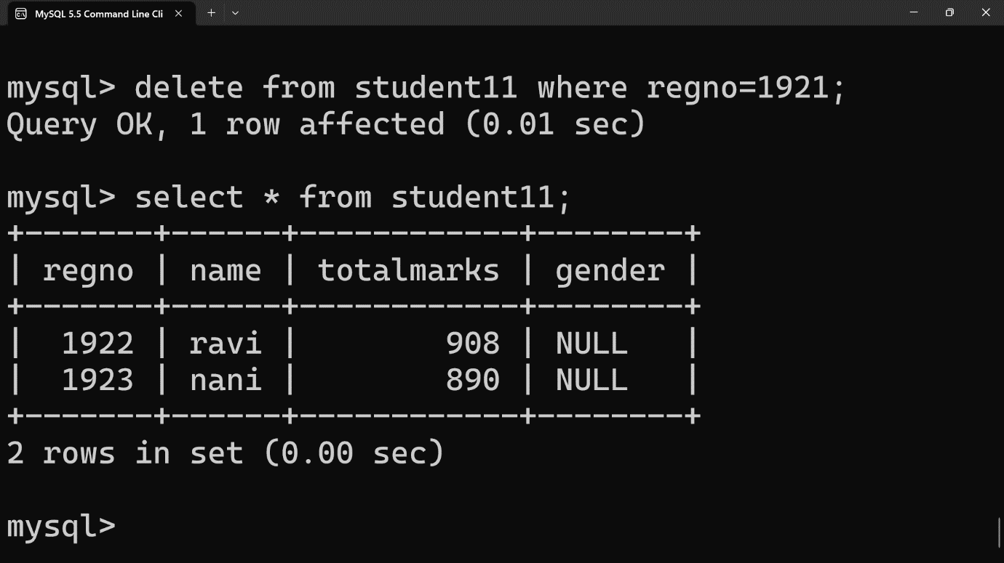

**TRUNCATE TABLE**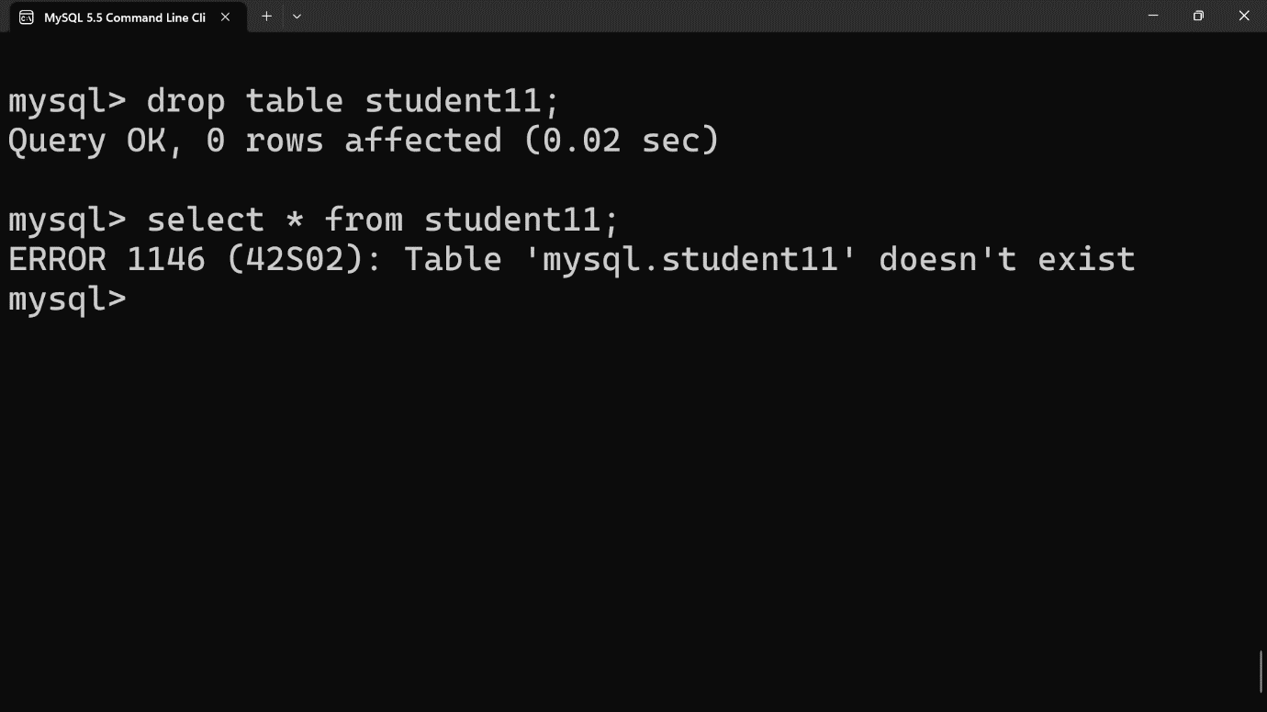

**RESULT:**

Tables are created, altered and modified using DDL commands.